

**Senior Design Project Progress Report**

**EE 492 Senior Design Project Planning**

**Project Title**

By:

First Name Last Name

First Name Last Name

First Name Last Name

**December 2021**

Faculty Advisor: Dr. Faculty Advisor, Affiliation

Industry Advisor: Dr./Mr./Ms. Industry Advisor, Affiliation

Client: Dr./Mr./Ms. Client, Affiliation

(Please ask how they like their name and affiliation to appear on the report)

Project Website: https://sites.google.com/site/

**Acknowledgments**

Thank you note to anyone who helped you!

# Abstract

Nicely written abstract.

Table of Contents - This list must be generated automatically!

To be generated later.

**Abstract** **2**

**List of Figures - This list must be generated automatically not by hand!** **5**

**List of Tables - This list must be generated automatically not by hand!** **6**

**Problem Statement (Must be 0.5 page)** **7**

**Introduction (Must be 0.5-1page) –** **8**

**Literature Review & Previous Works (Must be 1.5-2 pages)** **8**

**Methodology (Must be 0.5 page)** **8**

**Challenges & Risks (Must be 1-0.5 page)** **8**

**Project Requirements Make a complete and meaningful sentence** **8**

Marketing Requirements (MR) – Make a complete and meaningful sentence 9

Engineering Requirements (ER) - Make a complete and meaningful sentence 9

**Implementation** **9**

System Architecture 9

Budget/Parts List 10

Project Schedule 13

**List of Tests – Must include 5-10 major tests.** **14**

Summary of Tests 15

Description of Tests 15

**Ethics of the Engineering Profession and Our Project (Must be 0.5 page)** **15**

**References** **17**

# 

# List of Figures - This list must be generated automatically!

To be generated later.

# List of Tables - This list must be generated automatically!

To be generated later.

# Problem Statement (Must be at least 0.5 page)

Currently at Sonoma State, students constantly show up late to class with the excuse “there was no parking (in this small section you specifically explain what the problem is: students arrive to class late, cars drive on campus very fast, small underground sensors require energy and it is very difficult to change their batteries and recharge them, micro-breweries cannot have a controlled environment to replicate….

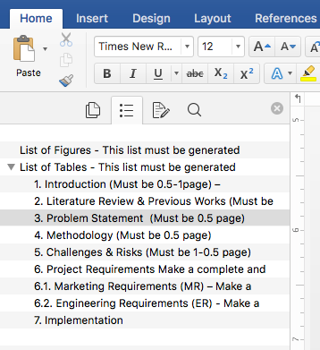

You should see the levels in your Navigation Pane:

# Introduction (Must be 0.5-1page)

Headers must be automatic – Use the available formatting (492-Header3)! Use the arrow keys to change the level: 1.2, 1.3, 1.1.2, etc.

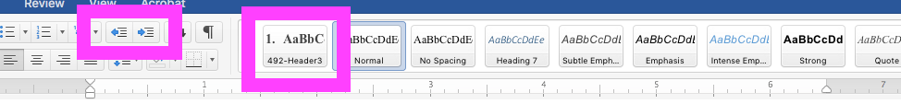

In most parking lots at SSU, there is almost no available spots at certain times of the day …what is the general issue? [1] <<- This is how you reference. All references must be AUTOMATIC. Do not manually reference.

In this work our goal is to achieve….

In the next section we review some of the products that

# Literature Review and Previous Works (Must be 1.5-2 pages)

There are similar products…. For example, in [1] authors proposes… MDSxE is yet another product which is based on ultrasonic waves [2]. ….Explain how different solutions are different from each other. Don’t just copy and paste. [2] <<- This is how you reference

# Methodology (Must be at least 0.5 page)

Our team will solve the proposed problem by using one pair of laser sensors at one entrance/exit of the –

how do you plan to solve the problem that you state above?

How is your solution difference from all other solutions you mentioned in Section 1.1 – literature review?

# Challenges and Risks (Must be 0.5-1 page)

A large challenge with our project is determining if two cars are entering and leaving simultaneously. Our program that determines an entrance or exit must be able to determine count

What are the challenges of this project as you see it?

# Project Requirements Make a complete and meaningful sentence

In this section we define the marketing and engineering requirements. Explain the difference between each.

## Marketing Requirements (MR) – Make a complete and meaningful sentence

1. The system will monitor all available parking spots.
2. The system will operate without interruption for a regular workday.
3. The control box will not block regular parking lot operations.
4. The system will sense temperature, pressure, and humidity.
5. The collected data will be visualized on a publicly accessible website.

## Engineering Requirements (ER) - Make a complete and meaningful sentence

1. The system will recognize parking spots within a 10 ft x 10 ft area (MR-1).
2. The system battery life will last at least 15 hours (MR-2).
3. The dimensions of system control box will not exceed 10 cm x 20 cm x 4 cm (MR-3).
4. The temperature sensor will have an accuracy of ±5 °F (MR-4).
5. The pressure sensor will have an accuracy of ±200 hPa (MR-4).
6. The humidity sensor will have an accuracy of ±5 RH units (MR-4).
7. The system will push collected data to the cloud and update the web interface every 10 minutes (MR-5).

# Implementation

Explain you implementation approach. Start with a paragraph not a picture! Explain what you are doing.

## System Architecture

Start with a paragraph not a picture! Explain what you are doing.

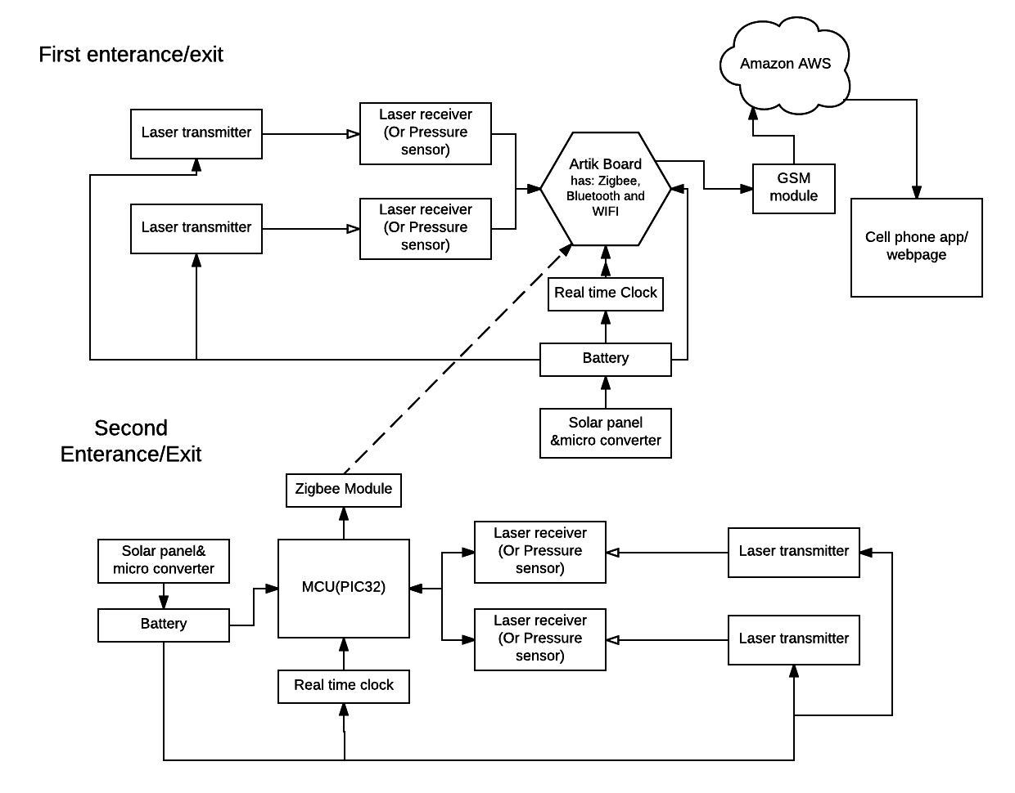

**Fig. 1** All figures must have caption and figure number!

## Budget/Parts List

Start with a paragraph not a tale! Explain what you are doing.

**Table 1** All figures must have caption and figure number!

|  |  |  |  |  |  |
| --- | --- | --- | --- | --- | --- |
| Part/ Quantity | Price | Description | Link | Test | ER# |
| Amazon AWS  (1) | $5.00 | Amazon cloud service to send all the data to. Charges per million messages sent | https://aws.amazon.com/websites/ | FT.1 | ER.3 |
| SPT Security Outdoor Dual-Beam Photoelectric Sensor  (2) | $32.00 | Laser sensors used to detect entry or exit into the lot | http://www.sears.com/spt-security-out-door-dual-beam-photoelectric-sensor/p-SPM8064831908?sid=IDx20110310x00001i&gclid=CLWL-vvG788CFUdafgodUKENVw&gclsrc=aw.ds | FT.1 | ER.3 |
| EM Wave Detection Sensor V 3.0 | $16.98 | EMF sensor to detect a change in the electromagnetic field | http://www.ebay.com/itm/like/280687552013?lpid=82&chn=ps&ul_noapp=true | FT.1 | ER.3 |
| Samsung ARTIK boards | $100 | Used to connect the system to the Cloud | http://www.digikey.com/product-detail/en/SIP-KITNXB001/1510-1316-ND/5825102?WT.mc_id=IQ_7595_G_pla5825102&wt.srch=1&wt.medium=cpc&WT.srch=1&gclid=CKuuxpjH788CFQp3fgodgUMJCg | FT.1 | ER.3 |
| PIC32 microcontroller | $4.00 | MCU to connect the sensors into a complete system | http://www.mouser.com/ProductDetail/Microchip/PIC32MX220F032B-I-SP/?qs=hort8UWU32rVXheI4RPqdQ%3D%3D&gclid=CIrCqKPH788CFUxsfgodx9cMEQ | FT.1 | ER.3 |
| Microchip BT | $10.61 | Bluetooth connection for sensors to communicate with the MCU | http://www.nextwarehouse.com/item/?2279535_g10e | FT.1 | ER.3 |
| Solar Panels | $18.00 | Used to recharge the battery system | http://www.invertersupply.com/index.php?main_page=product_info&products_id=4930&cPath=0_603&gclid=CNr45c_H788CFUpNfgodcdgHJA | FT.1 | ER.3 |
| 12 pack of Lithium-Ion Batteries | $19.13 | Rechargeable batteries | http://www.tmart.com/12-Pcs-Neutral-18650-3-7V-4-2V-5000mAh-Rechargeable-Lithium-Battery-Deep-Blue_p191438.html?cc=USD&fixed_price=us_us&gclid=CNne_OPH788CFQ9xfgoddFEAog | FT.1 | ER.3 |
| Android Application | $25.00 | Start up the app | http://www.techrepublic.com/blog/software-engineer/app-store-fees-percentages-and-payouts-what-developers-need-to-know/ | FT.1 | ER.3 |
| Total Cost | $517.53 | | | | |

## Project Schedule

Start with a paragraph not a picture! Explain what you are doing.

**Table 2** All figures must have caption and figure number! Table captions are on top, while figure captions are at the bottom.

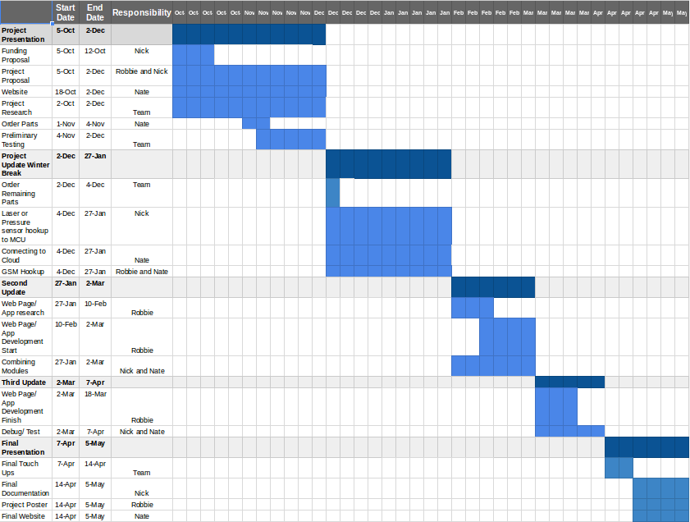

# List of Tests (Must include 5-10 major tests)

We divide this section to Functional Tests (FT) and System Verification Tests (ST). ….

See this for more details: <http://web.sonoma.edu/users/f/farahman/sonoma/courses/es492_493/lecture/Test_Plan_Example.pdf>

## Summary of Tests

Below, we present a summary of tests that are conducted so far.

**Table 3** Summary of conducted tests.

|  |  |  |  |
| --- | --- | --- | --- |
| Test Number | Objective | ER to address | Notes |
| FT.1 | Amazon Web Services (AWS | ER.2, ER.4 | In Progress |
| FT.2 | Asdasdmasdjk | ER.2, ER.4 | Passed |
|  |  |  |  |

## Description of Tests

Amazon Web Services (AWS): Be able to get an account and use the service as a cloud server to send and pull data from (ER.2, ER.4)

* Results: On the week of October 19th - 26th, we were able to get an AWS account set up, which was not too difficult. From this account created, we
* Proof of Concept: A message we sent to a cell phone using AWS
* Requirements Satisfied: (ER.2, ER.4)

Asdasdmasdjk

* Results: On the week of October 19th - 26th, we were able to get an AWS account set up, which was not too difficult. From this account created, we
* Proof of Concept: A message we sent to a cell phone using AWS
* Requirements Satisfied: (ER.2, ER.4)

# Ethics of the Engineering Profession and Our Project (Must be 0.5 page)

* In this section you need to write one full page and elaborate on the following points within the context of your project
* Make sure you use minimum of TWO references and cite them throughout the text.
* PAY ATTENTION to the RUBRIC. This is how you get a grade.
* What is the definition of ethical design? Explain how it is related to your product.
* What are the ethical considerations about the technologies that you are using in your project?
* How sustainable is your project? What happens to the device when it stops working? How does it impact the environment and its resources? Are you using biodegradable products? Are you using a modular design approach?
* How useful is this product to the human well-being? Do we really need it? Does it really help people, animals, environment? What social, environmental, cultural, implications could this project potentially create?
* Have you thought about moral issues? e.g., is it ok to trap animals and then kill them? It is ok to automate the factory, and give jobs away to robots?
* How is your design interface? Have you thought about people with disabilities? How can they use your products? Can an older person with limited vision and movements use your product?
* Could there be a potential harmful aspect to your project that you should consider? For example, could generating high power RF signal be harmful for the people living in the neighborhood?

# References

(Must use minimum of 5 IEEE references, minimum of 5 web page refences – all references must be sited throughout the document Use <https://scholar.google.com> for correct formatting – Read more here <https://ieee-dataport.org/sites/default/files/analysis/27/IEEE%20Citation%20Guidelines.pdf> - )

1. S.-T. Inc, "RedStorm™ parking guidance system | parking vehicle counting system | parking car count system," Signal-Tech, 2002. [Online]. Available: http://www.signal-tech.com/products/parking/redstorm_parking_guidance_system. Accessed: Oct. 5, 2016.
2. Sdjkasdjkasdjk
3. Askjdas dash

ATTNETION:

* Remove all the white spaces in the document
* Make sure fonts are consistent
* All figures must be readable
* Your schedule must be readable
* You are not allowed to copy anything from any source unless you clearly reference it.